Game Design Document

Fill up the Following document

1. Write the title of your project.

Ans: Super Mario Game Level - 1.

1. What is the goal of the game?

Ans: To reach to the castle.

1. Write a brief story of your game?

Ans: There is a Character name Mario and he has to reach to the

Castle but there are enemies in the path like Goomba and Turtle

and we have to save him from enemies and help him to

reach the castle.

1. Which are the playing characters of this game?

* Playing characters are the ones which respond to the user based on the input from the user
* Cars, monkeys, dinos, wizards etc, are the playing characters in the game.

|  |  |  |
| --- | --- | --- |
| Number | Character Name | What can this character do? |
| 1 | Mario | Jump,run,kill enemys |
| 2 | Goomba | It can kill us |
| 3 | Turtle | It can kill us but if we jump on it its shell goes and kill other enemys. |
| 4 | Mushroom | We can increase our hight. |
| 5 |  |  |
| 6 |  |  |
| 7 |  |  |
| 8 |  |  |

1. Which are the Non Playing Characters of this game?

* Non Playing characters are the ones which don't have an action or a behaviour when the user interacts with the game.
* Hurdles, stones, bananas, coins, etc are non playing characters in the game.

|  |  |  |
| --- | --- | --- |
| Number | Character Name | What can this character do? |
| 1 | coins | We get’s coin |
| 2 | Bricks | If we touches it we bounce it is a kind of wall. |
| 3 | Pipes | We can jump over it and some pipes are there from which we can go under ground. |
| 4 | Mystery Box | We can get coins, mushroom and followers. |
| 5 |  |  |
| 6 |  |  |
| 7 |  |  |
| 8 |  |  |

Draw your imagination of this game. What does this game look like?

* Draw the game either on your computer or on paper,
* Add images of scenes of the game to show each of the playing and non-playing characters at least once.

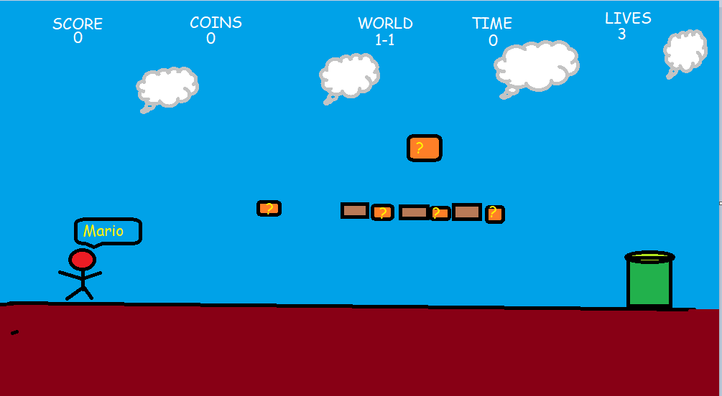

Miss I have drawn in paint.

How do you plan to make your game engaging?

Ans: Mario has to not touch the enemy and complete the goal with out

Dyeing.